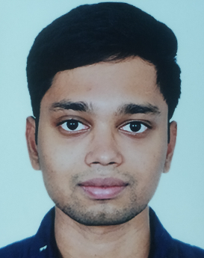**M.DHANUSH KUMAR**

39-9-29, Labbipet, Vijayawada, Andhra Pradesh

9677155158 (cell)

Mailmedhanushm@gmail.com (email)

www.linkedin.com/in/mandadhanush (LinkedIn)

**CARRIER OBJECTIVES:**

* Work with an organisation which would help to improve my skills.
* Take a responsible position in the company.
* Apply better machine learning algorithms to solve real world problems.

**EDUCATION:**

* **CURRENT:**

Pursing Integrated M. Tech (software engineering), degree anticipated May 2021 VIT University, Chennai, Tamil Nadu

CGPA: 8.99

* **CLASS 12:**

Andhra Pradesh State Board

Percentage: 94

* **CLASS 10:**

Andhra Pradesh State Board

Percentage: 88

**WORK EXPERIENCE:**

* Worked as intern for Accuracy software solutions in Hyderabad for 2 months.
* Worked as Technical Head for ACM Student Chapter.
* Attended work shop on Hybrid mobile android app development.

**CERTIFICATION:**

* NPTEL certified on “Introduction to Machine learning” an online learning platform.
* COURSERA certified on “AI for everyone” an online learning platform.

**ACADEMIC PROJECTS:**

* Severity of drusen (categorizing eye disease) by soft computing Using mat lab.
* Sentiment analysis on tweets from twitter.
* Water Management System using IOT.
* Rice grading by image processing algorithms using mat lab.
* Relation between food search and food price worldwide using data mining algorithms.
* Digital Ticket Verification using java Applets.
* Software project estimation techniques like function point analysis, earned value analysis, constructive cost model using html, css, and java script.

**WORK SAMPLES:**

* Developed a windows application on “Patient management system” using visual studio.
* Created blog for VIT soft skills.

**SKILLS:**

* Languages Known are JAVA, C, HTML.
* Basic knowledge of MATLAB and IMAGE PROCESSING.
* Good Knowledge on data structure algorithms.
* Better Understanding on machine learning algorithms.
* Made a prototype on new idea like digital ticket verification in railways
* Strong commitment on given work.
* Continuous improvement and dedication are my strengths.

**ACHIEVEMENTS:**

* Awarded 100% of attendance for fall semesters 16-17 and 18-19.
* Awarded CPL rank in NCC during my secondary school education.
* Awarded with silver in 200mts running race in my secondary school education.

**PERSONAL INFORMATION:**

DATE OF BIRTH: 9th July 1998.

NATIONALITY: Indian.

**DECLARATION:**

I, Manda Dhanush Kumar, declare that all of the above information presented in this resume is certiﬁed, valid, and true to the best of my knowledge.